tSNR Summary (N=6)

Mean tSNR

Volume | Mean | Max | Min
ABCD | 35.1 | 123.0 | 0.1
In-plane | 29.2 | 93.0 | 0.2
HCP | 23.5 | 77.3 | 0.1
Surface
ABCD | 60.2 | 182.2 | 2.3
In-plane | 48.9 | 130.8 | 3.2
HCP | 46.6 | 141.6 | 2.1

ABCD in-plane HCP ABCD in-plane HCP
Surface
Volume
70
60
50
40
30
20
10
0

Median tSNR from ABCD Study during SST (MR750 subset) for reference

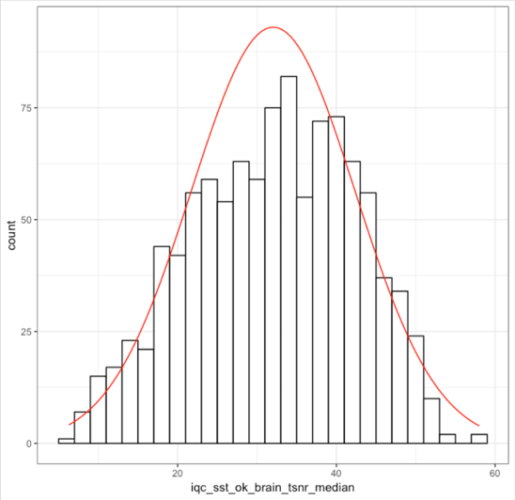
Mean = 32

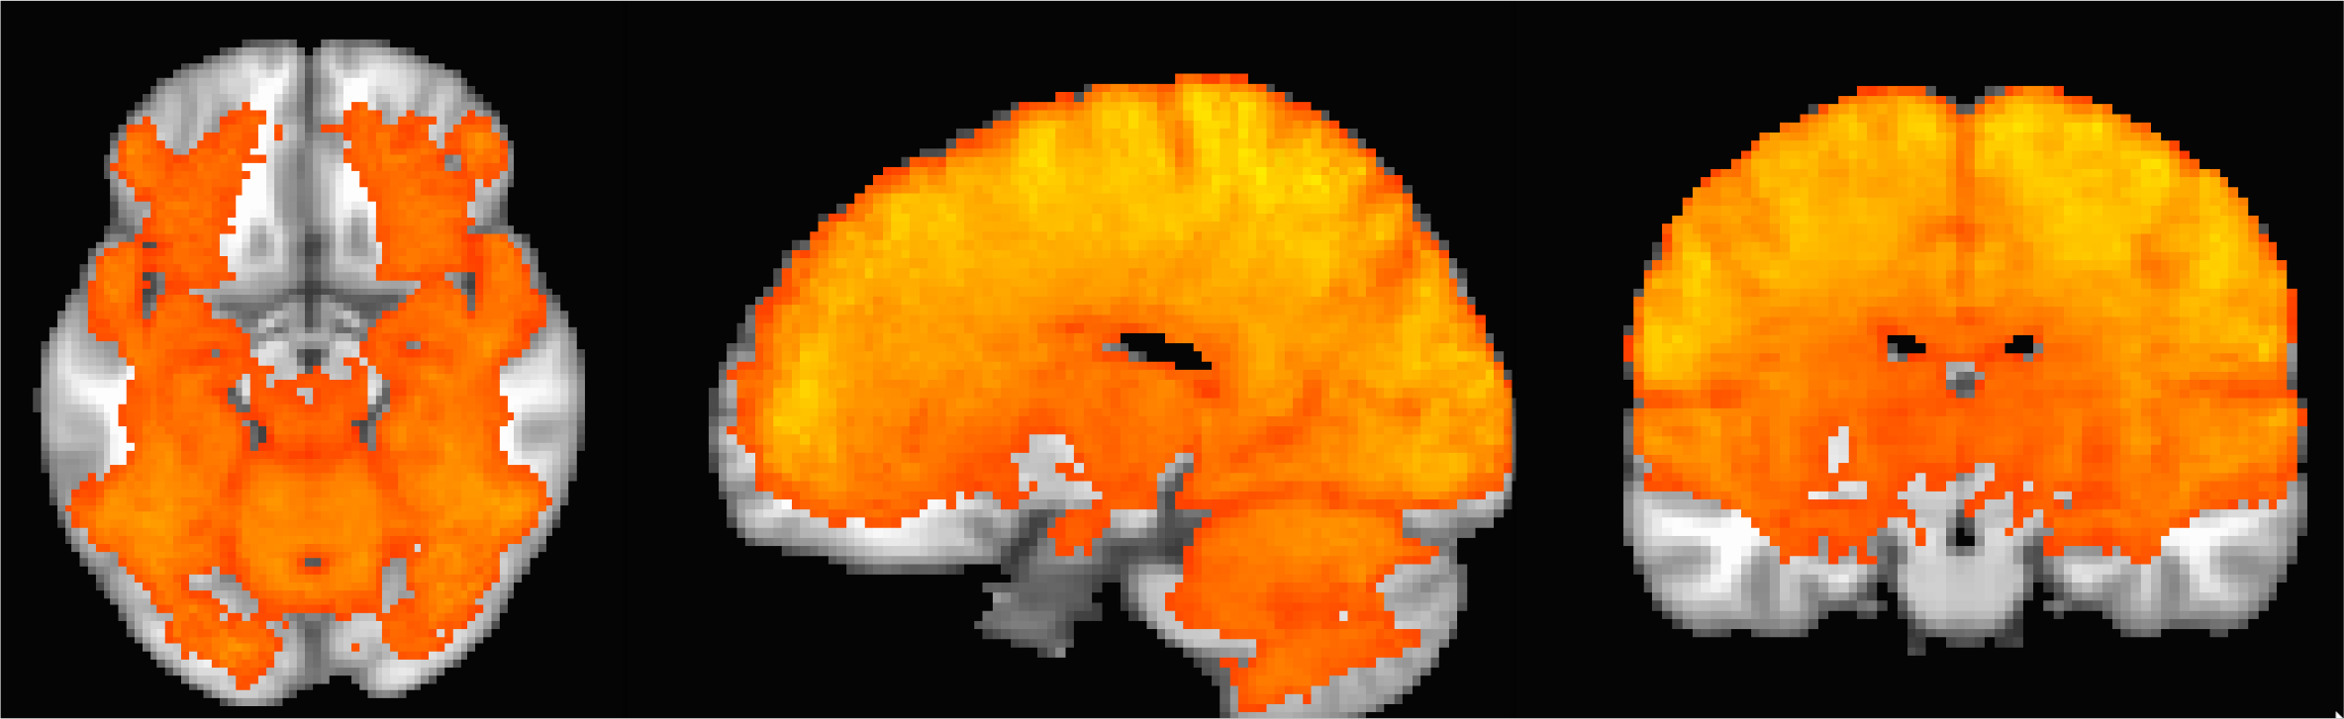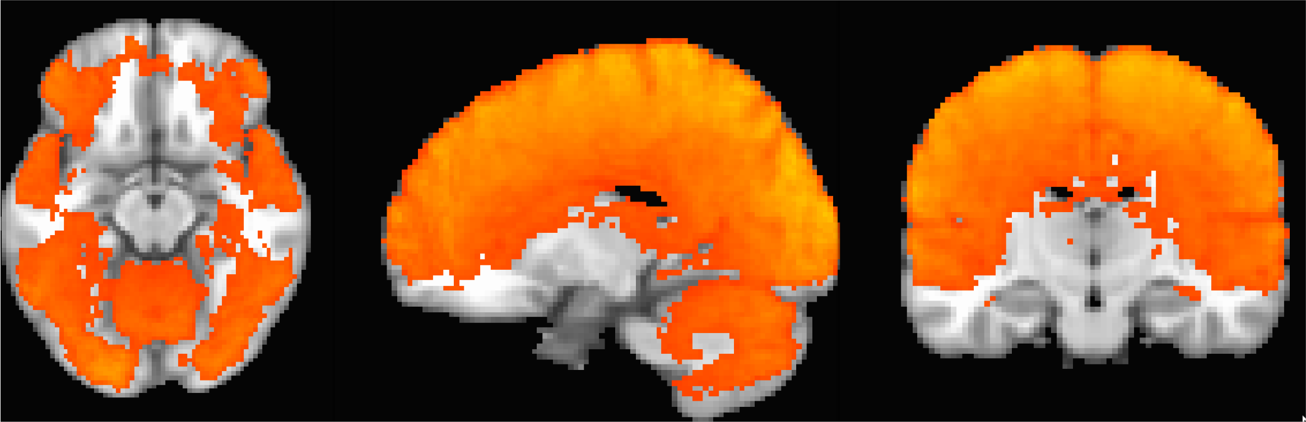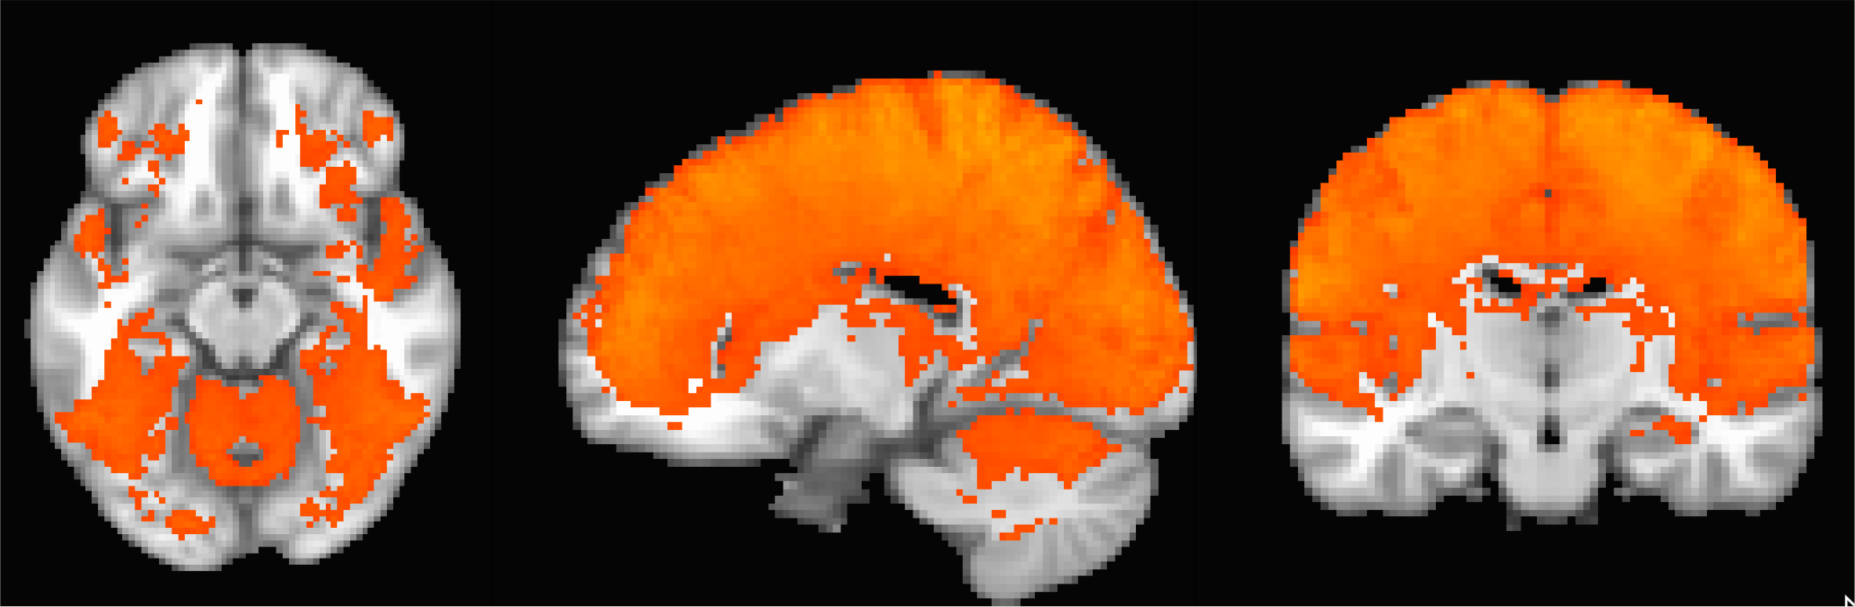

ABCD
850ms 2.4mm Mux=6

In-plane
900ms 2.4mm Mux=4 Inplane=2

HCP
900ms 2.0mm Mux=6
tSNR average (n=6) Threshold tSNR>20 max color=80

80

20

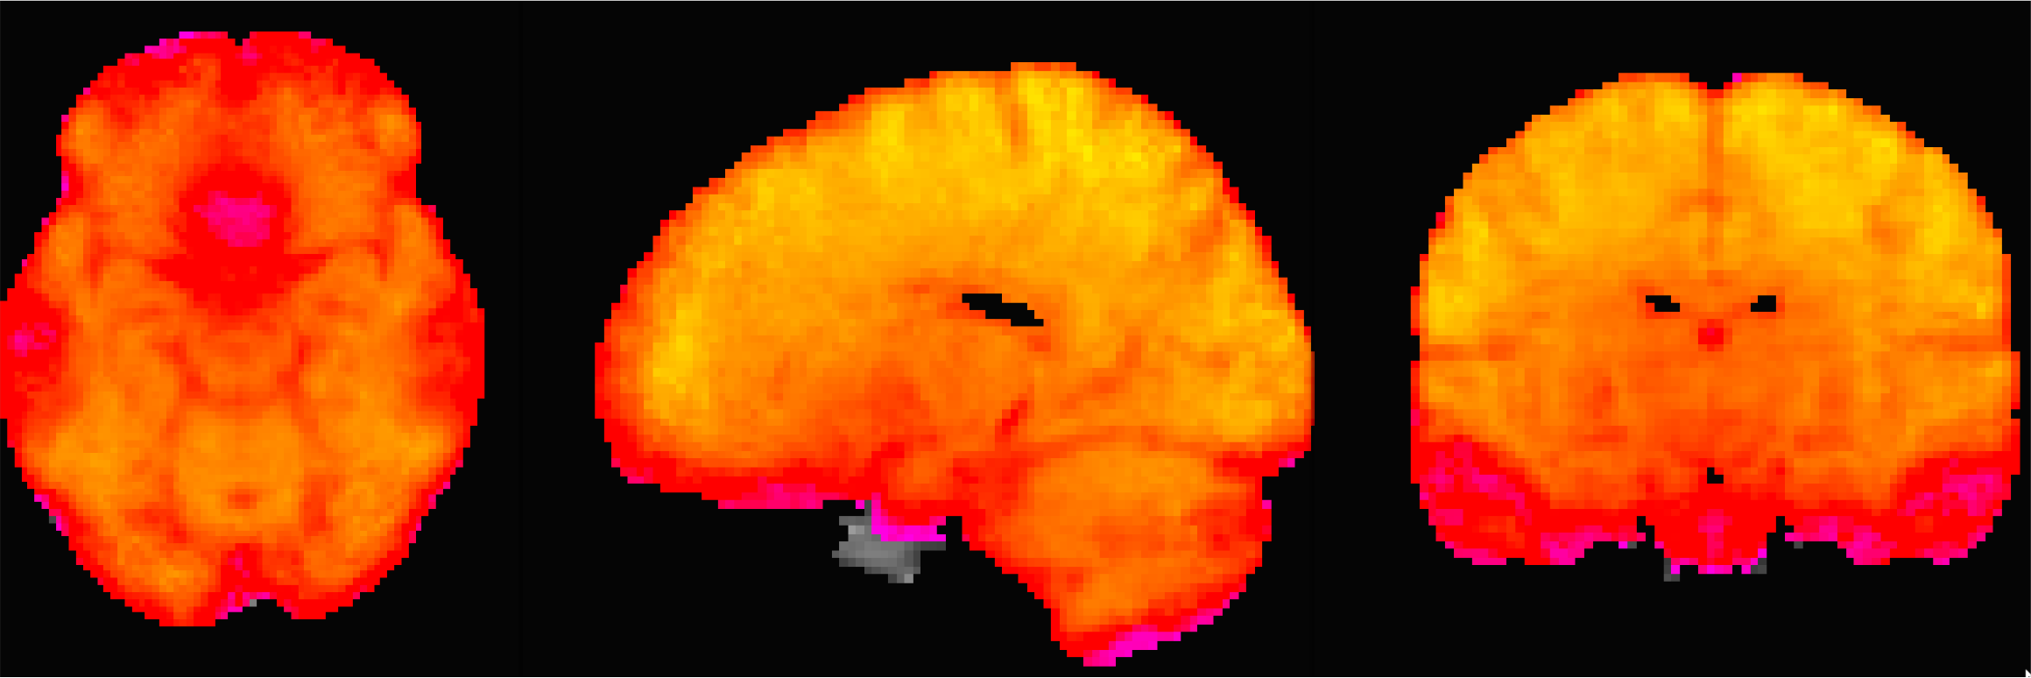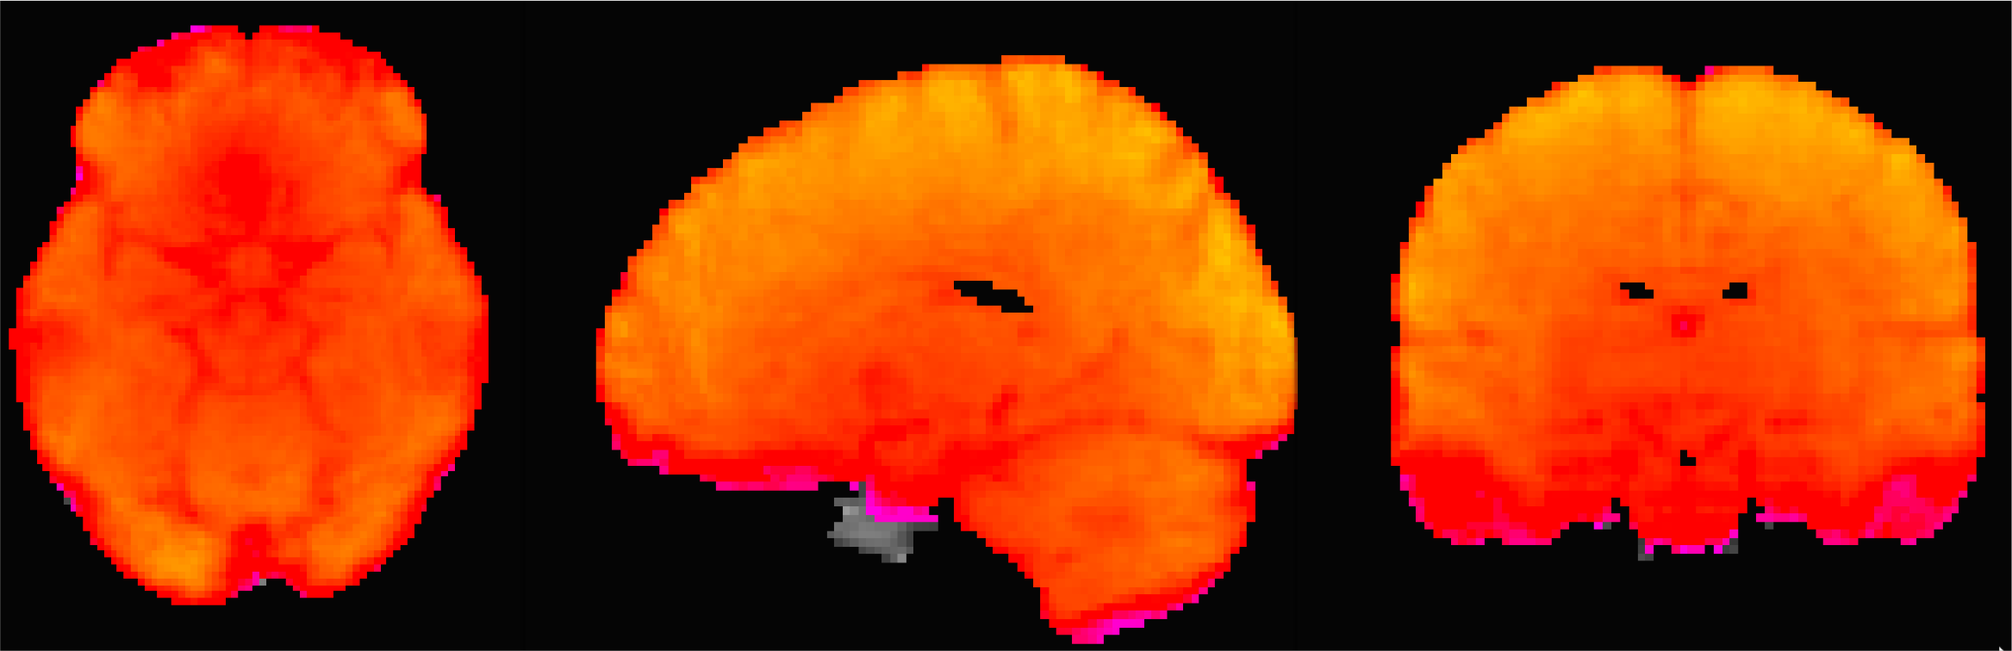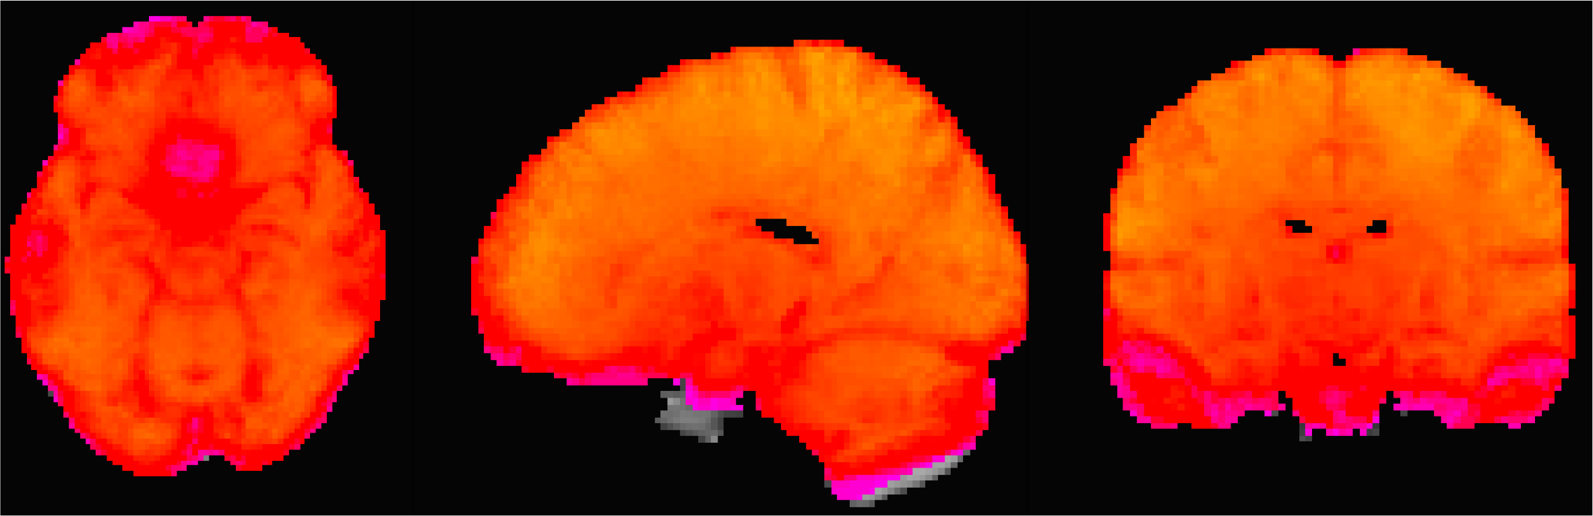

ABCD
850ms 2.4mm Mux=6

In-plane
900ms 2.4mm Mux=4 Inplane=2

HCP
900ms 2.0mm Mux=6
tSNR average (n=6)
unthresholded max color=80

80

0

Stop Signal Task data
- 2 runs of the stop-signal ABCD task for each sequence
- First ABCD, then in-plane, then HCP

- Indicate direction of arrow on go trial, inhibit response on stop signal
+
Go
→
+
ITI
Stop

ITI
Main contrast of interest – correct stop vs. correct go
←
→

Whole brain min/max, mean of positive/negative values by sequence

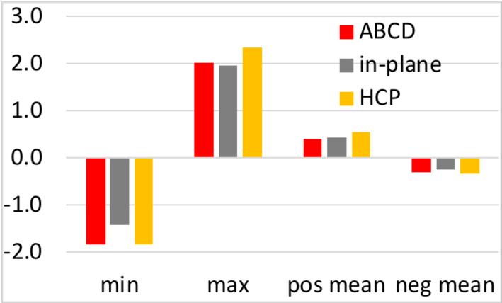

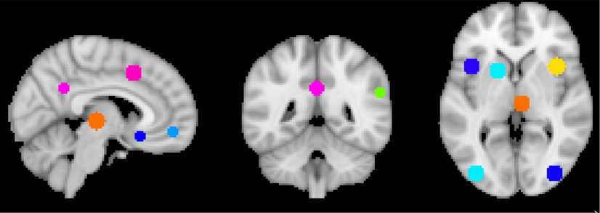
Meta-analysis peak ROIs

MNI peaks from meta-analysis (8mm sphere). Plus extra PCC, sgACC, and vmPFC regions

ROI Activity
bar= mean +/- SD of voxels within sphere line plot = max of voxels within sphere

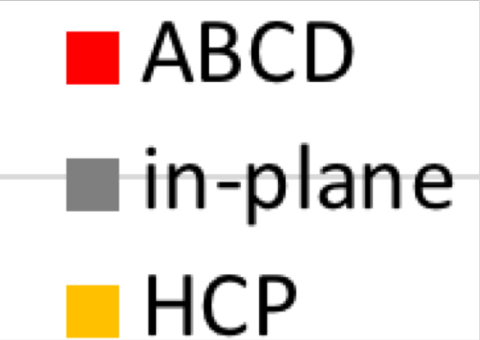2

1.5

1

0.5

0

-0.5

-1
L AI R AI R IFG R Thal L Put R MFG R IPL L MOG R MOG R PreC vmPFC PCC sgACC

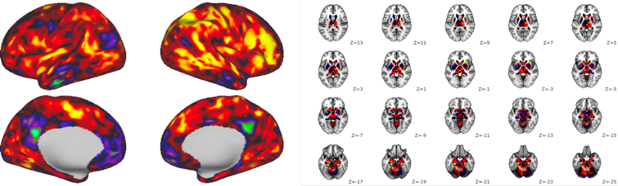
CIFTI Analysis ABCD
850ms
2.4mm
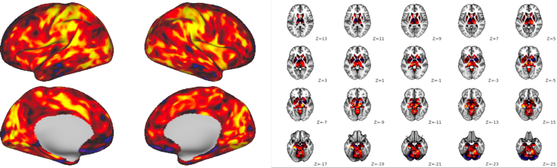
Mux=6

In-plane
900ms 2.4mm Mux=4 Inplane=2

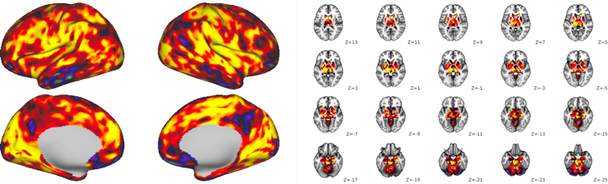
HCP
900ms 2.0mm Mux=6
Color bar = -1.5 to 1.5

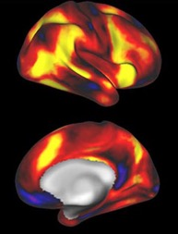
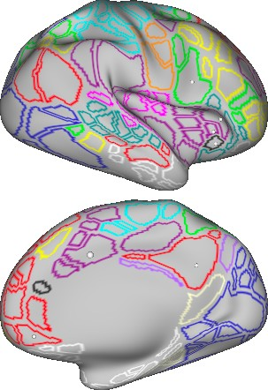CIFTI - Gordon Atlas Parcellation
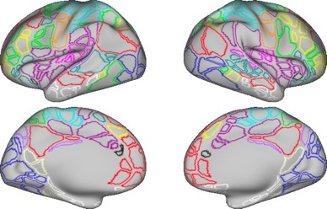
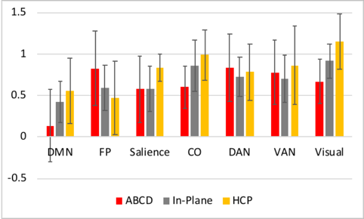
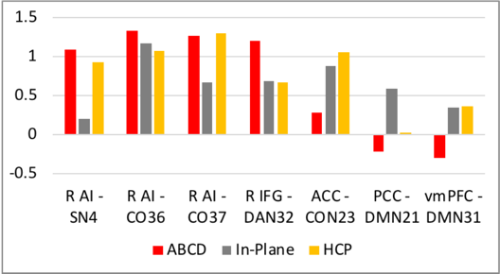
Network Averages +/- SD across ROIs
Selected ROIs

Subcortical CIFTI Space ROIs

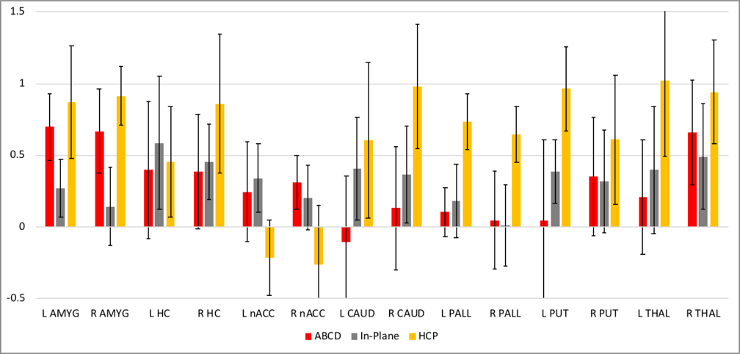

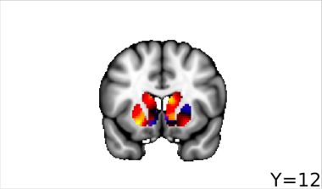
ABCD Comparison

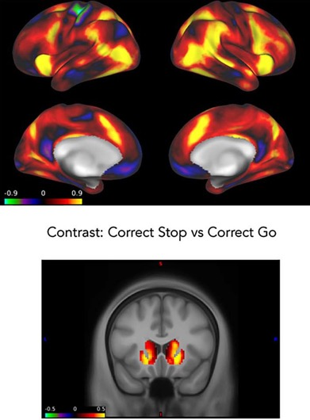
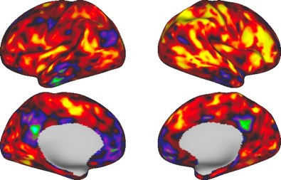
ABCD Paper – Cohen’s d map (n=750) Post-Upgrade Data: n=6

